Thaitastik
1330 New Hampshire Ave NW B2
Washington DC 20036

Tel: 202-643-9001

Email: thaitastik@gmail.com

www.thaitastik.com

Thaitastik Client Intake form
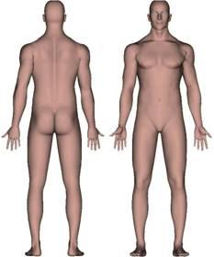
Please make an “X” over areas of concern.

Name: _____________________________

Date of Birth_______/_______/_______ Cell:(______) ________-__________
Please circle your answer
Sex Male Female
Is this your first Thai massage? Yes No
Are you pregnant? Yes No If yes, how many weeks?_____________
Do you have spinal problems or herniated discs? Yes No If yes Describe:____________________
Recent Surgeries? Yes No If yes Describe, Where on your body:____________________
Are you taking pain medication? Yes No
Are you taking anti-inflammatory medication? Yes No
I_______________________________________(Print name) understand that I experience any pain or discomfort during my session, I will immediately inform the practitioner. I also understand that the massage should not be considered a substitute for a medical or physical illness that I am experiencing. I also understand that certain contraindications exist for massage therapy and I will inform my massage practitioner immediately if any changes to my health profile occur. I agree that my massage practitioner will not be held liable for any negative effects if I fail to update my profile or provide complete information. Finally, I understand that any illicit or sexual suggestive remarks or advances will NOT be tolerated and will result in the immediate termination of the session with full payment.
Client’s Signature__________________Date______/_______/_______

